CSV Loader: Route XY Method
Version 1.1, December, 2008

TABLE OF CONTENTS

1. Quality Assurance Statement or Document Control 3
1. Author 3
2. Document History 3
3. Quality Assurance 3
2. Route XY Summary 4
3. Route XY Process 4
Step 1. Create the File Definitions. 5
    - SURF - File Columns 7
    - SURF - File Destinations 8
    - SURF_LINE - File Columns 10
    - SURF_LINE - File Destinations 11
Step 2. Load CSV File into NM_LD_asset_TMP. 12
Step 3. Pre-Process Line Data 15
Step 4. Load Asset. 17

Quality Assurance Statement or Document Control

Document History

Document History
Revision | Date | By | Description
1.0 | February, 2008 | Paul Sheedy | Initial Release
1.1 | December, 2008 | Adrian Edwards | Revised document title

Quality Assurance

Document Details
File | Prepared By
CSVLoader_RouteXY_v1.0.doc | Paul Sheedy
Document Name | Reviewed By
Exor Documentation
Version | Approved for issue by
1.0
Date of Issue | Support Manager
February, 2008

Route XY Summary
The Route XY method allows an administrator/user to load assets into the Highways application using a Route identifier and XY coordinates. The loader process uses the XY coordinates to determine the nearest mile point along the specified route. Continuous and Point assets can be loaded using this method.

For continuous assets, two pairs of XY coordinates must be provided, depicting the start point and end point of the linear asset. The XY coordinates must appear on separate lines in the CSV file. To ensure the loader is provided enough data to successfully load an asset using the Route XY method, the following fields MUST be included in the CSV file:

- A Route identifier column
- A Northing column
- An Easting column
- An LFK column which ties together two CSV input lines
- A LOCATEREF column which indicates whether the CSV input line describes the Start XY location or the End XY location.
- Attribute column(s) describing the asset

Route XY Process
The Route XY loading process is depicted in the following diagram.
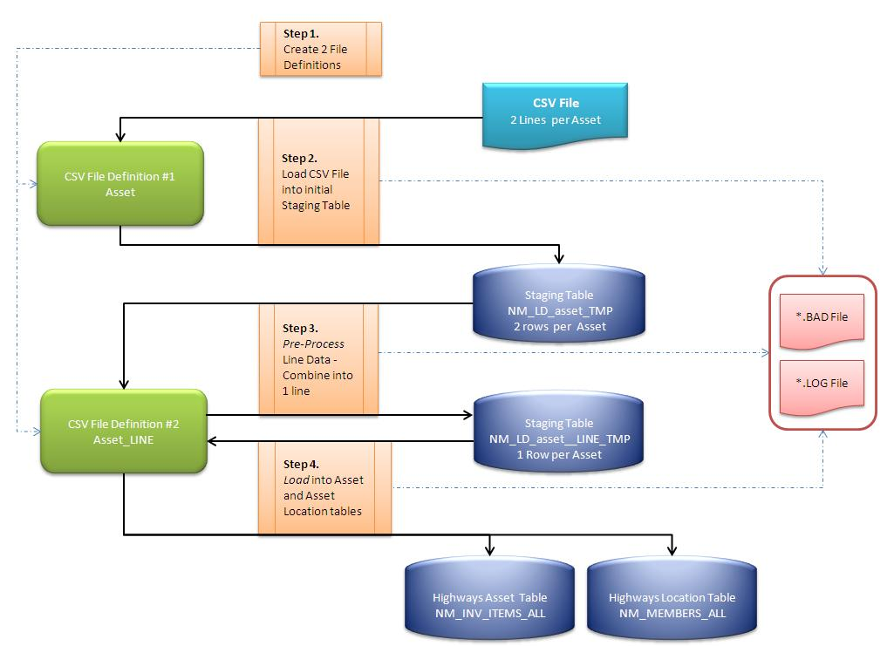

The CSV file example used in this section describes the process of loading a Surface Type linear asset (SURF).

The CSV file to be loaded contains the following data:

1,8202,01,20070601,150303,CSL,D,S,8201,C,10,5253525.90,816748.90
1,13501,01,20070601,123518,CSL,D,E,8201,C,10,5186807.90,757232.80
1,5701,01,20070601,163311,CSL,D,S,5701,C,100,5260927.10,759081.70
1,6804,01,20070601,133353,CSL,D,E,5701,C,100,5196553.60,732120.20

The SURF asset has the following attributes:

Attribute | Description
Surface Type | Code used in a domain lookup
Recordkey | Unique identifier from the field measuring equipment
Feature Class Code | Indicates the type of asset; in this case, 01 indicates Surface Type
Acquisition Date | The date the measures were taken
Acquisition Time | The time of day the measures were taken
Survey Agency | A code representing the agency conducting the measurement
Survey Technique | A code representing the method of measurement
XSP | The cross sectional position of the measures (R, L, or C)

The following information is required in any CSV file being loaded using the Route XY method.

Column | Continuous, Point | Description
LFK | Continuous only | An identifier that ties together the record holding the Start XY record with the End XY record
LOCATEREF | Continuous only | Indicates whether a record contains the Start XY or the End XY. (S, E)
Route Identifier | Continuous and Point | Indicates which route the asset will be placed on.
Northing | Continuous and Point | Indicates the Northing position of a coordinate pair
Easting | Continuous and Point | Indicates the Easting position of a coordinate pair.

Step 1. Create the File Definitions.

Two File Definitions must be created to load continuous assets via the Route XY method. The first File Definition includes information that will allow the Loader to read the CSV file, and then load its contents into a staging table (NM_LD_asset_TMP).

The second File Definition allows the Loader to read the first staging table, combine the start and end records into one record, and then write out the combined record into the second staging table (NM_LD_asset_LINE_TMP).

To create the CSV File Definitions, run the CSV File Definitions Tables form as shown below. (note: by executing the CSV_METADATA(‘asset’) procedure from SQL*Plus, both of the File Definitions will be created automatically. This custom procedure assumes the asset parameter is the 4 letter asset code and that the asset is Continuous).

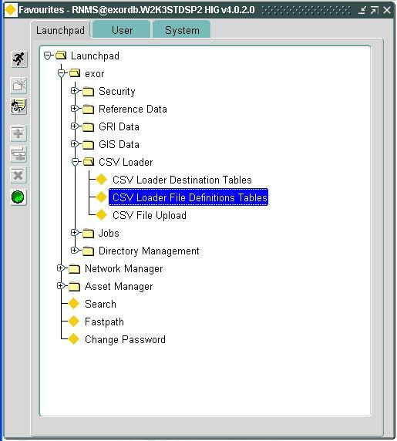

A form is presented that allows the creation of a File Definition. The top part of the form is described below.

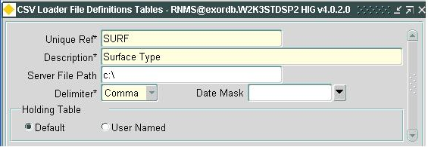

Where:

Field | Description
Unique Ref | This value uniquely identifies this CSV File Definition on the Open list during execution of a load. For continuous assets, there are two file definitions, though only the first is shown and selectable on the Open list. The Unique Ref should be sufficiently descriptive so that the user knows which asset it defines.  For the second File Definition, the name must begin with the same name as the fist File Definition, end with a _LINE suffix.  In the example above, the Unique Ref for the second File Definition would be SURF_LINE.
Description | A free form text field that describes the CSV File Definition
Server File Path | Indicates the folder that the BAD and LOG files are written to. This folder must be accessible by the user running the CSV Loader (UTL_FILE_DIR must include this folder).
Delimiter | Indicates the character used to separate fields in the CSV file.
Date Mask | Indicates the format that will be used to read DATE fields from the CSV file.
Holding Table | Indicates whether the default Staging Table will be generated and used to load the asset, or a custom table.

The file definition information is specified on 2 tabs: File Columns and File Destinations. The data contained in the definition:

- Describes the CSV file (File Columns)
- Describes which asset fields to populate with the CSV data (File Destinations)
- Describes the data to be used to locate the asset. (File Destinations)

In our example there are two File Definitions; SURF and SURF_LINE. They are each described below

SURF - File Columns
The File Columns settings for SURF would be:

Seq | Column Name | DataType | Char Len
1 | SURFTYPE | NUMBER
2 | RECORDKEY | VARCHAR2 | 10
3 | FEATCLASSCODE | VARCHAR2 | 4
4 | ACQDATE | VARCHAR2 | 8
5 | ACQTIME | VARCHAR2 | 6
6 | SURVEY_AGENCY | VARCHAR2 | 10
7 | SURVEY_METHOD | VARCHAR2 | 25
8 | LOCATEREF | VARCHAR2 | 1
9 | LFK | VARCHAR2 | 10
10 | CROSS_SECT_POS | VARCHAR2 | 2
11 | ROUTENUMBER | VARCHAR2 | 15
12 | NORTHING | NUMBER
13 | EASTING | NUMBER

The Seq column must represent the actual ordinal position of the attribute in the CSV input file. If the Seq columns are incorrect, the CSV Load process will fail. In the example above, each column in the CSV file is used – there are no gaps in the SEQ numbering sequence. If data in the CSV is to be skipped, the Seq number must be adjusted accordingly.

Once the File Columns information has been defined, press the [Save] button on the menu toolbar followed by the [Create Holding Table] button on the File Definitions form. This will create the first staging table for the SURF asset type (NM_LD_SURF_TMP).

SURF - File Destinations
There are typically two File Destinations for each File Definition. The File Destinations describe where the loader should place the CSV data – typically in either an Asset table (NM_INV_ITEMS)or a Location table or view (V_LOAD_INV_MEM_ON_ELEMENT_XY).

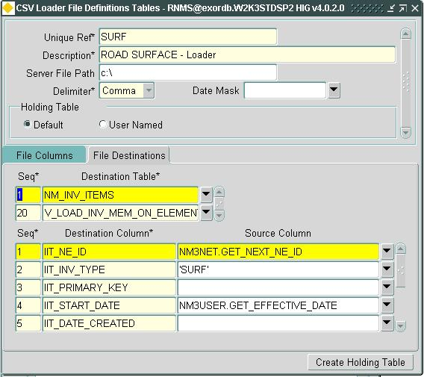

The Seq, Destination Column, and Source Column specifications will differ depending on the Destination table that is highlighted.

For the NM_INV_ITEMS destination table, the column values will be:

Column | Description
Seq | Indicates the sequence of the NM_INV_ITEMS column. This is typically auto-generated and not modifiable.
Destination Column | This lists ALL of the columns in the NM_INV_ITEMS table.
Source Column | This indicates the information that will be populated into the corresponding NM_INV_ITEMS column. Only those columns in NM_INV_ITEMS that will be populated, will have values – all others will remain NULL.  All columns that come from the CSV file must be preceded by a table descriptor. The default table descriptor is the name of the File Definition. In this example, the default descriptor would be SURF.  Some useful column values include:  NM3NET.GET_NEXT_NE_ID – generates a unique identifier for a new asset  NM3USER.GET_EFFECTIVE_DATE – generates the date the user has selected for the Effective Date – the default is Today.

The values for NM_INV_ITEMS are presented below, though only those Destinations with Sources are shown.

Seq | Destination Column | Source Column
1 | IIT_NE_ID | NM3NET.GET_NEXT_NE_ID
2 | IIT_INV_TYPE | ‘SURF’
4 | IIT_START_DATE | NM3USER.GET_EFFECTIVE_DATE
9 | IIT_ADMIN_UNIT | 2
27 | IIT_CHR_ATTRIB26 | SURF.SURFTYPE
28 | IIT_CHR_ATTRIB27 | SURF.FEATCLASSCODE
29 | IIT_CHR_ATTRIB28 | SURF.ACQDATE
30 | IIT_CHR_ATTRIB29 | SURF.ACQTIME
31 | IIT_CHR_ATTRIB30 | SURF.SURVEY_AGENCY
32 | IIT_CHR_ATTRIB31 | SURF.SURVEY_METHOD
34 | IIT_CHR_ATTRIB33 | SURF.LOCATEREF
146 | IIT_X | SURF.EASTING
147 | IIT_Y | SURF.NORTHING
154 | IIT_NUM_ATTRIB101 | SURF.RECORDKEY
159 | IIT_NUM_ATTRIB106 | SURF.LFK
10 | IIT_X_SECT | SURF.CROSS_SECT_POS

For the V_LOAD_INV_MEM_ON_ELEMENT_XY destination table, the column values will be:

Column | Description
Seq | Indicates the sequence of the NM_INV_ITEMS column. This is typically auto-generated and not modifiable.
Destination Column | This lists ALL of the columns in the V_LOAD_IN_ON_ELEMENT_XY table/view.
Source Column | For the SURF File Definition and any other first File Definition using Route XY as the load method, the Source Columns are left NULL. Only the second File Definition’s (SURF_LINE) will contain values.

SURF_LINE - File Columns
The purpose of the SURF_LINE File Definition is to create and populate the second staging table (NM_LD_SURF_LINE_TMP) used to load assets via the Route XY method.

The File Columns settings will be used to create the NM_LD_SURF_LINE_TMP staging table; the File Destinations specifications will be used to populate it.

The SURF_LINE File Columns settings are specified in a manner nearly identical to that of SURF, with two additions: EASTING_END and NORTHING_END. These two additional columns are required in the staging table since one record holds the starting and ending XY coordinates.

The SURF_LINE File Column settings are:

Seq | Column Name | DataType | Char Len
1 | SURFTYPE | NUMBER
2 | RECORDKEY | VARCHAR2 | 10
3 | FEATCLASSCODE | VARCHAR2 | 4
4 | ACQDATE | VARCHAR2 | 8
5 | ACQTIME | VARCHAR2 | 6
6 | SURVEY_AGENCY | VARCHAR2 | 10
7 | SURVEY_METHOD | VARCHAR2 | 25
8 | LOCATEREF | VARCHAR2 | 1
9 | LFK | VARCHAR2 | 10
10 | CROSS_SECT_POS | VARCHAR2 | 2
11 | ROUTENUMBER | VARCHAR2 | 15
12 | NORTHING | NUMBER
13 | EASTING | NUMBER
14 | NORTHING_END | NUMBER
15 | EASTING_END | NUMBER

Once the File Columns information has been defined, press the [Save] button on the menu toolbar followed by the [Create Holding Table] button on the File Definitions form. This will create the second staging table for the SURF asset type (NM_LD_SURF_LINE_TMP).

SURF_LINE - File Destinations
The File Destinations settings for SURF_LINE differ from those of SURF only in that the Source Columns for V_LOAD_INV_MEM_ON_ELEMENT_XY are included. The source columns for the NM_INV_ITEMS File Destination are identical for SURF_LINE and SURF (see specification above).

The V_LOAD_INV_MEM_ON_ELEMENT_XY specifications are:
Seq | Destination Column | Source Column
1 | NE_UNIQUE | SURF_LINE.ROUTENUMBER
2 | NE_NT_TYPE | ‘NRTE’
3 | BEGIN_X | SURF_LINE.EASTING
4 | BEGIN_Y | SURF_LINE.NORTHING
5 | END_X | SURF_LINE.EASTING_END
6 | END_Y | SURF_LINE.NORTHING_END
7 | IIT_NE_ID | IIT.IIT_NE_ID
8 | IIT_INV_TYPE | ‘SURF’
9 | NM_START_DATE | IIT.IIT_START_DATE

Step 2. Load CSV File into NM_LD_asset_TMP.

To load the CSV file into the initial staging table, open the CSV File Upload form, as shown below.

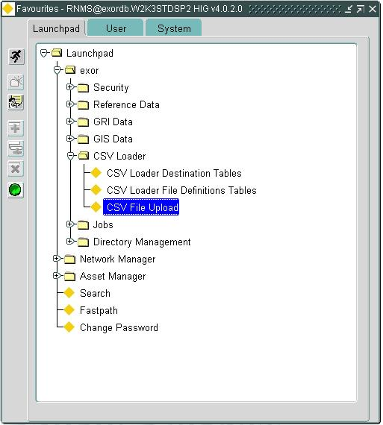

From the CSV Web form that appears, select the CSV File Definition for the asset you would like to load.
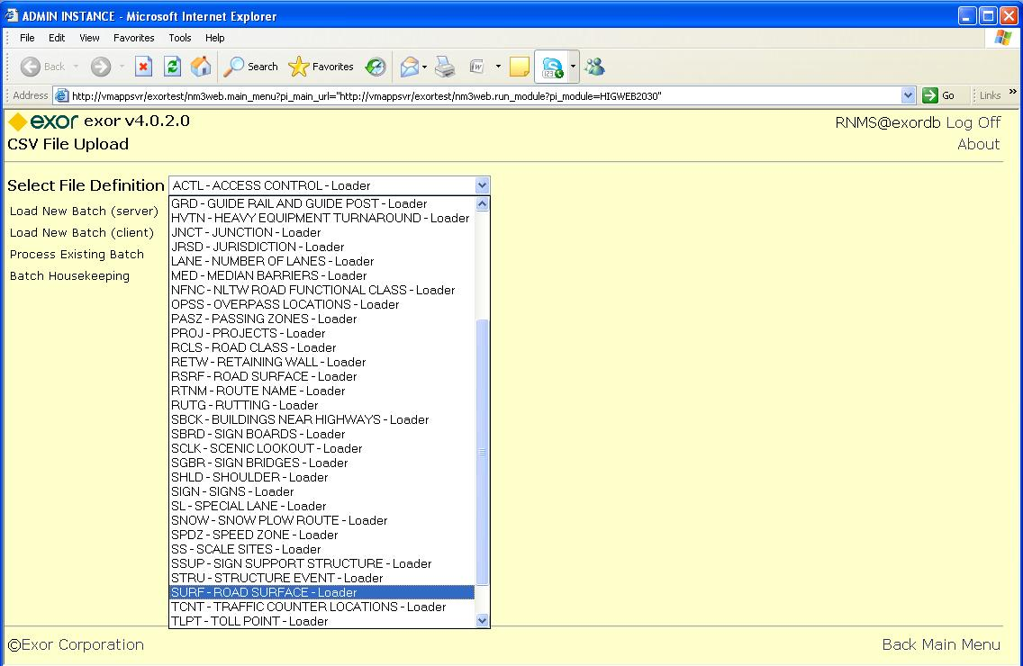

Select whether the CSV file is located on the Server or a Client machine, and then click on the Continue button.

On the FileName form, select the CSV file from the Browse dialog, select the type of load (batch or interactive) then click on the Continue button.

The following form will appear, which lists the status of the effort to populate the first staging table. In this example, the NM_LD_SURF_TMP table has been populated with 46 records. These records represent 23 assets – 2 records per asset.

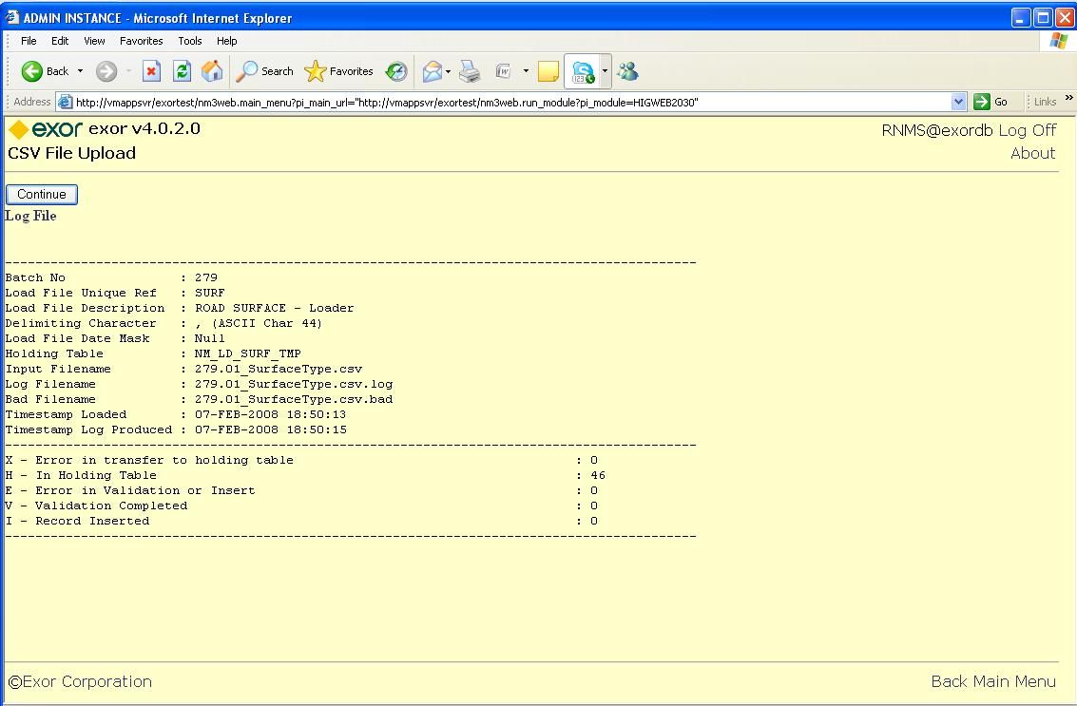

The information on this form is stored in a LOG file with the name shown above. The log file can be accessed by clicking on the words Log File, just under the Continue button. Once accessed, the Log file can be saved to an asset log folder or printed.

If errors are generated at this stage of the load process, it can be the result of any of the following:
- a misspecification in the Seq – resulting in the CSV Loader processing the wrong data against an asset attribute
- a missing domain value
- a data type error in the File Columns settings

A BAD file is generated which includes those records that failed this stage of the load process. You can either:

- continue to load the records that successfully loaded into the first staging table, fix the records in the bad file, and re-run the load using the BAD file as input;
- abort the load, fix the problem, and try again.

Step 3. Pre-Process Line Data
Once the results of step 1 are acceptable, click on the Continue button to bring up the following form:

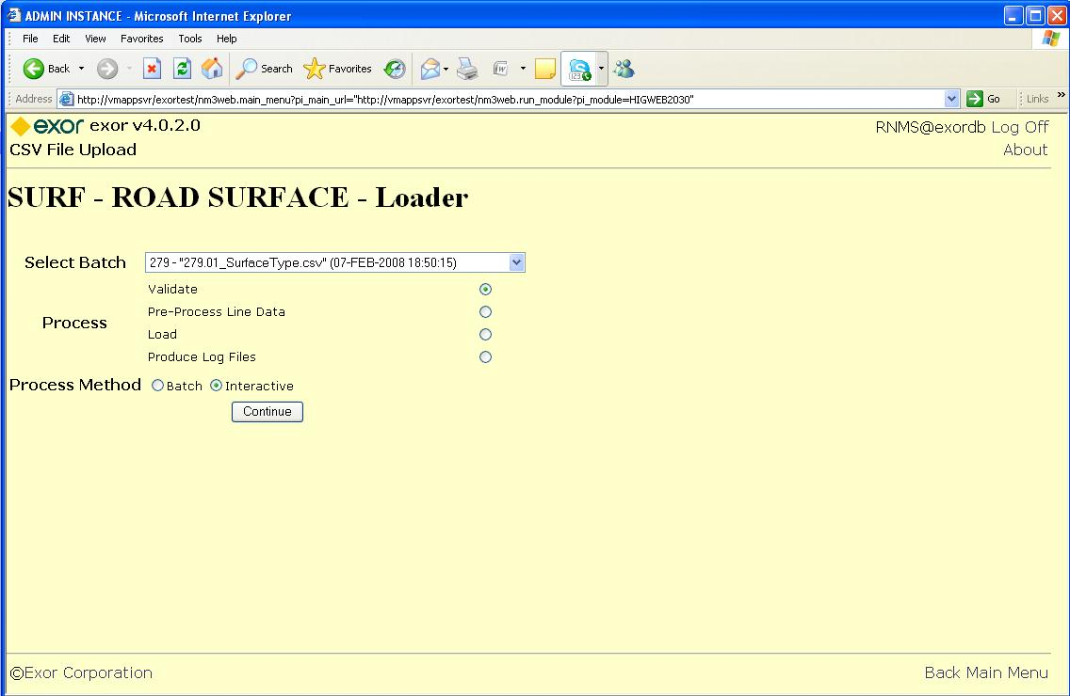

Using the Route XY method, the next step is to select the Pre-Process radio button and click the Continue button. (do not select Validate!)

The following form appears:

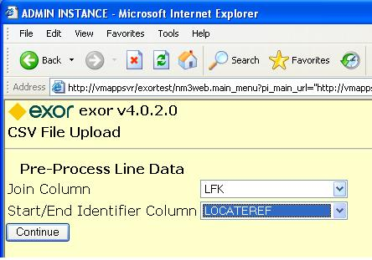

In order to join the two records per asset from the first staging table into one record, the CSV Loader will need to know how to join the two related records together. The Join Column is the field that holds a common value for each pair of records that defines one asset. The Start/End Indentifier Column tells the CSV Loader which of the two records holds the Start XY and which holds the End XY. In our example, LFK, and LOCATREF are the columns that hold the information needed.

Once this information is provided, click on Continue. The CSV Loader then attempts to create one record for each asset. If the effort is successful, then the previous form is presented, allowing you to Load the preprocessed data. If the effort fails, another status form is presented

Step 4. Load Asset.

Once the data has been successfully pre-processed, you are ready to load it into Highways. To load the asset, select the Load option and click Continue on the form shown below.

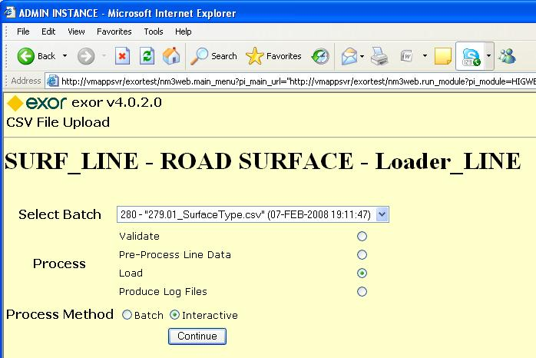

The CSV Loader will read the SURF_LINE File Definition and attempt to place the assets onto the network. If there are errors in the process, as shown below, they are detailed in the LOG file and those records causing errors are saved to a BAD file for reprocessing.

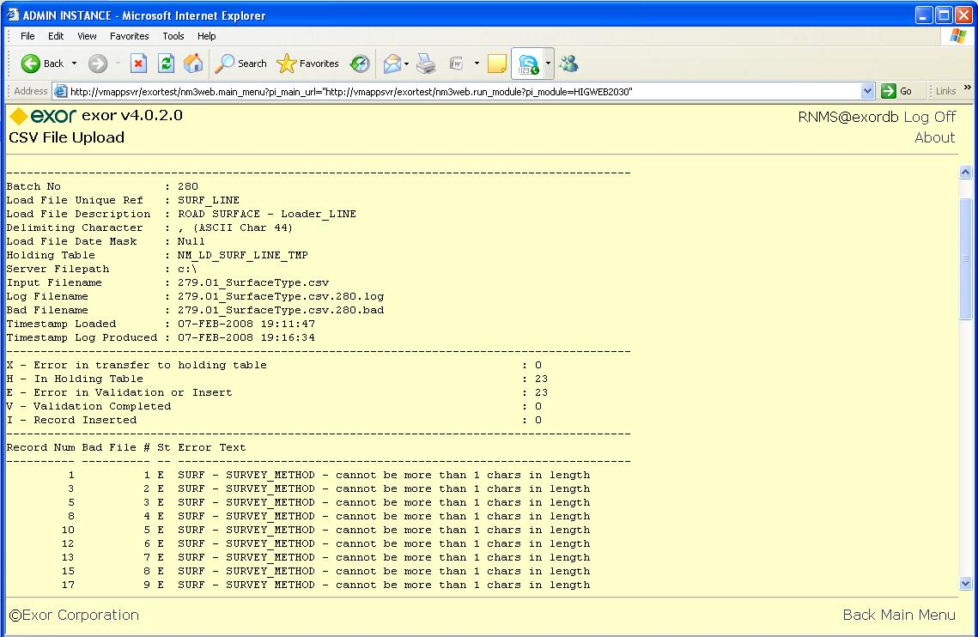

In the example above, the SURVEY_METHOD asset attribute has a character size limit of 1, though the data in the staging table has a length greater than 1.

Each LOG File contains the following information:

Field | Description
Batch No | Each load attempt is given a unique batch number. This allows a batch to be unique identified and/or resubmitted.
Load File Unique Ref | The name of the File Definition processed
Load File Description | The description of the File Definition being processed
Delimiting Character | The character specified as the Delimiter for the CSV File processed
Load File Date Mask | The mask used to read dates from the CSV File processed
Holding Table | The name of the staging table being used during this stage of the load
Server File Path | The folder on the Server where LOG files will be stored
Input Filename | The name of the CSV File processed
Log Filename | The name of the log file generated by this load attempt
Bad Filename | The name of the BAD file generated by this load attempt
Timestamp Loaded | The date/time the load process began
Timestamp Log Produced | The data/time the log file was generated
X-Error in transfer to holding table | Number of records that failed during the load into the holding table
H – In Holding Table | Number of records that were read from the previous stage and successfully placed into the current holding table
E-Error in Validation or Insert | Number of records unsuccessfully validated
V-Validation Complete | Number of records successfully validated
I-Record Inserted | Number of asset records that loaded

Following the above information is a section of the LOG file that describes any errors that occurred during the load. Each error record contains the following information:

Field | Description
Record Num | Record number from the original CSV file
Bad File # | Record number that the CSV File record is in the BAD file
St | Status code from the LOG
Error Text | A description of the error encountered during the load effort.

Following the Error Status section of the LOG file is the BAD File section. The BAD File section lists the contents of the BAD File. The BAD File can be used as input to a subsequent load attempt (used primarily if the data was good, but the specification was not)

